# Course Notes

## Introduction to Prompt Engineering

### What is Prompt Engineering

* Prompt: Instructions and context provided to an AI for a certain task.
* Prompt Engineering: The practice of developing and optimizing prompts to efficiently use an AI for a certain task.
* To get a high-quality accurate result you need to be able to optimize your prompts.
* To craft a good prompt you need to help the AI understand the purpose and context of your task.
* We need to understand the capabilities of these LLM’s and their limitations.
* LLM’s are sensitive to the way prompts are framed.
* A multidisciplinary branch of engineering focused on interacting with Artificial intelligence through the integration of fields including Software Engineering, Machine Learning, Cognitive Science, Business, Philosophy, Psychiatry, Computer Science.

### Why is Prompt Engineering Even a Thing?

* The larger the model size the more abilities emerge.
* Once LLM’s Model scale (training FLOPs) got to around the size 10^22 The abilities of LLM’s exploded.
* It was also scientifically proved that changing the way LLM’s were prompted coaxed more abilities out of them. Even in smaller LLM’s
* LLM’s were never actually trained to do the things it does. We don’t know exactly how they do it. Prompt Engineering is part of the quest to figure this out.
* Improving prompt quality by 5 does not necessarily improve LLM result performance by 5. The prompt could spark something and leaps in LLM ability can be uncovered.

### Breaking GPT

* The only time LLM’s think is when they are typing
* So they will think in the order they type. Or in the order you prompt it to type.
* Prompting LLM’s to do task in the right order can have significant effect on it’s performance and the results that appear.

### Applied Prompt Engineering

* Applying prompt engineering principles, knowledge, and skills to real-world tasks.

### Large language models can do jaw-dropping things. But nobody knows exactly why.

* <https://www.technologyreview.com/2024/03/04/1089403/large-language-models-amazing-but-nobody-knows-why/>
* Figuring out why LLM’s can do amazing things is a key to big steps forward in AI.

### Emergent Abilities of Large Language Models

* <https://arxiv.org/pdf/2206.07682>
* This published study considers an ability to be emerging if it is not present in smaller models but is present in larger models.
* The emergence of such abilities raising the question of whether further scaling could expand the range of abilities of LLM’s.
* 1 Introduction
  + Emergence is when quantitative changes in a system result in qualitative changes in behaviour.
* 2 Emergent Abilities Definition
  + An ability is emergent if it is not present in smaller models but is present in larger models.
  + When visualised via a scaling curve where x axis is model scale and y axis is performance, performance is almost random until a certain point in the x model scale size when performance becomes consistently considerably better than random.
  + This qualitative change is known as phase transition.
  + Today’s language models have been scaled primarily along three factors:
    - Amount of computation
    - Number of model parameters
    - Training data set size
  + FLOPS or floating-point operations per second, is a metric for computer performance that quantifies the number of floating-point calculations a system can perform in one second.
  + Model parameters typically scale in line with training compute FLOPS.
  + Emergent abitlities rely heavily on Model parameters and training compute scaling past a larger enough point.
  + Emergent abilities also rely on other factors such as not being limited by the amount of data, it’s quality, or the number of parameters in the model.
  + Today’s models are likely not trained optimally and this will improve in the future.
  + This paper aims to discuss examples of emergent ability in prior work.
* 3. Few-Shot Prompted Tasks
  + Few-Shot Prompting: A prompt engineering technique where you insert examples in your prompt, training the model on what you want the prompt to look like.
  + 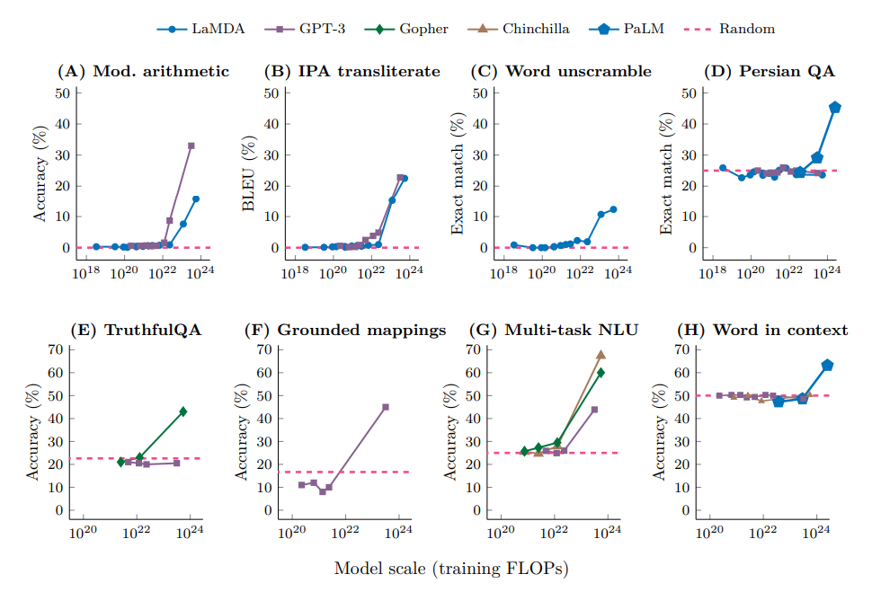
  + Few-Shot Prompting performance is random until a certain point of training compute and then accuracy of the Few-Shot prompting improves significantly.
* Augmented Prompting Strategies
  + Reasoning tasks, especially those that involve multiple steps have been challenging for LLM’s
  + Chain of thought prompting:
    - A prompting strategy that helps get better results from LLM’s when multi step reasoning is required for a task.
    - Process of guiding LLM’s to produce a sequence of intermediate steps before giving final response.
    - Only showed better results when 10^23 FLOPs scale was reached.
  + Instruction Tuning:
    - Another strategy to communicate with LLM’s
    - Involves giving LLM instructions but not few-shot examples.
    - Only improves performance with much greater computation as well.
  + Program execution and model calibration are other strategies.
  + Typically it did not matter which strategy was used, it wasn’t until the LLM got large enough (more FLOPs, more parameters) that these emergent new abilities started to appear.
* Discussion
  + Further scaling could lead to more emergent abilities.
  + New architecture, higher quality data, or improved training procedures could help us see new emergent abilities in smaller models. Scale won’t necessarily be the only factor. There is some evidence of this already when comparing models.
  + Pre training could help us get more emergent abilities too.
  + Once emergent abilities appear in larger models we can hypothesize as to why and implement into the architecture or how we work with smaller models.

### Applied Prompt Engineering With NASA

* Training for way longer than we think might be all it takes in some instances to help an LLM be successful in completing tasks successfully.
* Burda and Edwards of OpenAI tried to teach an LLM to do basic Arithmetic and it was failing. And then it worked. The LLM could do basic arithmetic. And what was the trick. Simply doing more of the same. It’s seems there is a tipping point for some abilities that when the LLM get’s enough data, enough examples, a big enough data set it can then learn on it’s own. On this occasion the pair just gave the model way more examples of the arithmetic it wanted it to solve and presto, it worked.
* A lot of current AI advancements have come through trial and error rather than understanding what these LLM’s do and how or why they do it.

### Applied Prompt Engineering With NASA

* BIDARA:
  + A ChatGPT based chatbot that was instructed using prompt engineering.
  + Can guide users through the Biomimicry Institute’s Design Process, which is a step by step method to propose biomimetic solutions.
  + <https://github.com/nasa-petal/bidara> shows a massive prompt NASA used to create BIDARA.
  + Bigger isn’t always better with prompts.
  + The prompt:
    - Tells ChatGPT it is an expert in a certain field.
    - Tells ChatGPT it’s goal.
    - Effectively creating a custom ChatBot using ChatGPT
    - It creates a user workflow by telling ChatGPT to prompt the user through a series of steps to complete a task. This makes the process more user friendly with checks and reminders to do a good and complete job.
    - It creates a process of digestible steps for ChatGPT to follow.
    - Breaking tasks down into smaller clear steps for ChatGPT helps it be more accurate.
    - It requests the model to provide peer reviewed sources for it’s information. This biases the model towards being more accurate and avoiding hallucinations. This does not always work but where you can, bias the model towards being more accurate or effective.
    - Asking ChatGPT for evidence is one way of biasing it towards being more accurate.
    - This prompt gets the model to provide in depth explanations for what it says.
    - Provides extra helpful information.
    - Provides hints to help guide the model.

### Why Is Prompt Engineering Important To You

* It’s the key to using ChatGPT’s potential, productively and efficiently, to achieve your specific needs and goals while avoiding errors and biases.
* Sam Altman said, “Writing a really great prompt for a chatbot persona is an amazingly high-leverage skill and an early example of programming in a little bit of natural language.
* Andrej Karpathy said, “The hottest new programming language is English.
* Prompt engineering is effectively programming using natural language.
* Prompt engineering like programming is about using frameworks, the words in the right order and principles to solve a problem.
* ChatGPT is leader in most metrics right now.
* ChatGPT uses the GPT model.
* Different models have different strengths and weaknesses. Different use cases perhaps.
* <https://platform.openai.com/playground/chat?models=gpt-3.5-turbo>
  + The open ai playground

### Multi-Modality and Tools in LLMs

* ChatGPT can understand text and write text but it can also do other things.
* You can upload an image to ChatGPT for context and then ask questions, ask ChatGPT to solve a problem.
* ChatGPT can also produce images.
* ChatGPT can also access the internet and browse.
* Beware ChatGPT can hallucinate and is not always reliable. It can confidently give a clear answer and be wrong.
* Chat GPT can do python code execution. An example of this would be asking ChatGPT to calculate the Fibonacci sequence up to the 10th number. ChatGPT would then write the python code to do this, interpret and run the code and then give the result.

## How LLM’s Work

### Introduction to LLM’s

* NLP, Natural Language Processing:
  + A branch of computer science.
  + A branch of artificial intelligence.
  + Focuses on giving computers the ability to understand text and spoken words. To process natural language.
* LLM’s:
  + Large: lots of data, mostly text from the internet. And lots of parameters.
  + Language: focused on natural language text as opposed to say computer code.
  + Model: A machine learning system trained to perform certain tasks.

### Tokens

* At a high level you can think of tokens as words.
* Tokens are the way LLM’s, like ChatGPT, learn and speaks.
* We use words, LLM’s use tokens.
* Each word is NOT a token.
* LLM’s break down words into smaller pieces which are the tokens.
* Open AI says that 1 token is equal to about 0.75 words.
* Some words are broken down into multiple tokens. But we don’t know why?
* There are about 50,000 tokens.
* Each token has a token ID.
* LLM’s like ChatGPT are like a word guessing machine in that they look for patterns in text to predict what word should come next. They don’t actually think about something and come put with an answer? They just write a sentence by learning from text and predicting what words come one after another?

### Word Guessing Machines?

### Thinking Like LLMs – Roll a Dice

* Chat GPT and other LLMs won’t necessarily give you a random number. If you ask it to roll a dice it might surmise that the most common words to follow such a question is ‘The result is:’ And then it might determine that 4 is the most common word or thing to follow that. It won’t do the maths and determine a random number but rather the number or word that more often than not follows the words that preceded it.

### Inside LLMs

* GPT 3 is an LLM with 175billion parameters spread across 96 layers, trained on 300 billion tokens.
* Tokens: broken down word parts.
* 300 billion tokens is about 45 TB of text data (books, articles, websites etc.)
* If you have a blog or ever wrote something online it was probably used to train these LLM’s
* The inside of an LLM works a little like neurons in a brain and looks like this:
* 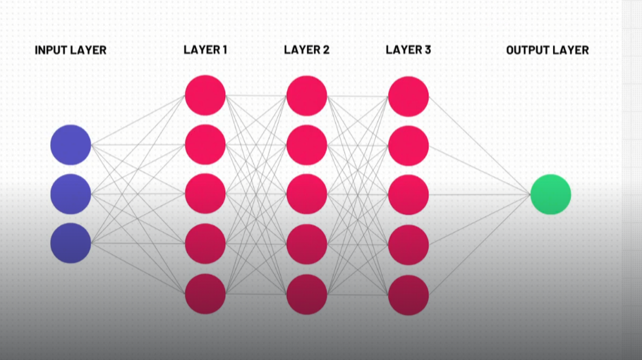
* Each of these dots is a neuron divided into different layers. GPT 3 has 96 of these layers.
* Parameters:
  + 175 billion of them in GPT 3
  + An umbrella term that encompasses:
    - Calculations going on inside the LLM
    - Two key types of parameters: weights and biases
    - Weights are the lines between the neurons. Each weight is a calculation.
    - At ach neuron there is a bias which can be also thought of as a calculation.
    - The weights and biases make up the total number of parameters.
* All the 96 layers except for the input and output layers are called hidden layers.
* We don’t know why when we pass something into and through these 175 billion parameters, we get the token that we do. Why it is accurate.
* 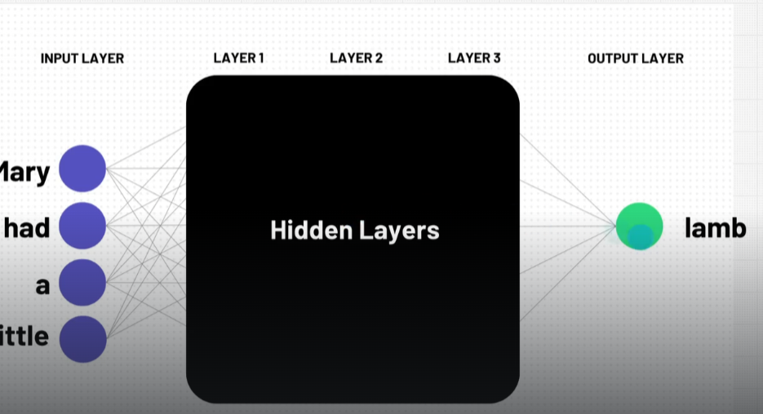
* The more tokens you train an LLM on and the more parameters there are, the smarter the LLM gets.

### The Transformer Model

* The key that unlocked LLM’s as we know them today.
* LLMs can pay attention to large amounts of text allowing it to get better context to help it determine what token or word should come next.
* GPT: Generative Pre-trained Transformer.

### The Training Process

* The LLM llama-2-70b, Meta’s LLM consists of one two files. A 140 GB parameters file and a run.c file containing 500 lines of code.
* This computer program utilising these two files requires and extensive and expensive training process to make it all work.
* The training process can be broken down into two steps.
  + Pre-training
    - Side note: There is no actual training phase.
    - Text data, the training data, a whole lot of it, is taken from the internet (and other places?)
    - -> It is then run through a lot of GPU’s
      * It takes millions of dollars and weeks and weeks, even months to process this text data.
    - -> Determines how parameters and weights calculate things
      * The program recognises patterns in the text data that us used to set parameter and weight values that will in turn determine whether a signal between “neurons” gets minified or amplified
      * Another way of looking at it, is it is compressing the data. It is lossy compression as you can’t get the original data back like unzipping a file.
    - At the end of this pre-training phase we have a base model that has some incredible abilities due to it being able to now predict what word (or token) comes next.
    - This Base Model is not the same things that we know of as a LLM.
    - This Base Model does not speak to you like a chatbot or have q and a abilities. It has not been Fine Tuned.
  + Fine-tuning
    - First a whole bunch of people, under strict guidelines, feed the Base Model a lot of ideal questions and answers. This will result in the parameters and weight values being adjusted again.
    - From here it will learn the ability to take in a question and provide an answer.
    - We don’t really know why feeding the model these q and a’s teaches the model that it should be giving q and a’s. We just know that it does.
    - Mechanistic Determinability is the field of trying to figure out what is happening in there.
  + RLHF
    - Another step that sometimes occurs.
    - The model gives answers and humans rank them.
  + The result: Assistant Model
    - Base Model + Fine-tuning = Assistant Model
    - Assistant model is what we would likely interact with.
    - Think ChatGPT

### Thinking Like LLMs – The Reversal Curse

* If A = B, then B = A
* LLM’s trained on A=B do not learn that B=A
* Just because it knows A > Mary Lee Pfeiffer is, B > Tom Cruise’s mom does not mean it knows that B > Tom Cruise is, A > Mary Lee Pfeiffer’s son.

### AGI Artificial General Intelligence

* Artificial intelligence that is at the human level.
* ASI, Artificial Superintelligence is different. Better or smarter than humans.
* The current ChatGPT models are not considered AGI or ASI
* Sparks of Artificial General Intelligence: Early experiments with GPT-4:
  + Is a Microsoft Research article.
  + The paper proposes that GPT-4 could be an early version of AGI.

### The World of LLM’s

## Our Prompting Framework

* She Standard Prompt: a prompt consisting of only a questions or instruction. The basic building block of prompt engineering.